WRITING TASK 1
You should spend about 20 minutes on this task.
The bar chart shows the percentage of adult male smokers in seven countries along with the world average in 2000 and 2015.
Summarise the information by selecting and reporting the main features and make comparisons where relevant.
Write at least 150 words.
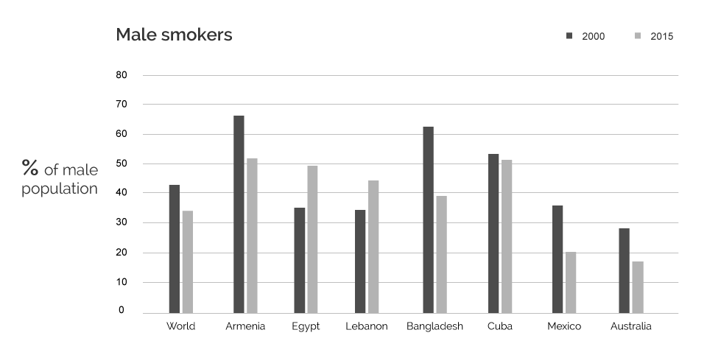

WRITING TASK 2
You should spend about 40 minutes on this task.
Some people believe that governments should have access to people’s mobile phone call records and messages for safety reasons. Others believe that this information is private and should not be available without permission.
Discuss both these views and give your opinion.
Give reasons for your answer and include any relevant examples from your own knowledge or experience.
Write at least 250 words.

